**About Us**

This system is developed by a team of five students. The students are from various disciples which include Information technology, Computer science and Biomedical Engineering. With the help of our project supervisor Mr. Abandoh-Sam we are to create this system.

**LIMS** is provides an efficient records management software and customer relationship management.

We make information regarding your health easy to get in our website.

We provide advice on the issues regarding your health in an easy way with a click of the button.

We have built the system help with your health needs.

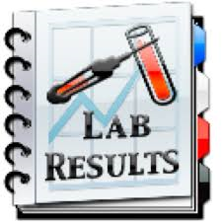LIMS is also design to assist you get your test result and doctor’s report on time without having to go the hospital.

We are dedicated to give you the best.